PG10Hasan

Rapid Prototyping – Assignment 2 Ant Prototypes Documentation

**Prototype 1 – Ant State Machine**

For this prototype, I planned to create 3 different states (work, aggro, gather) for ants but I had only finished work state in 1 hour. I was planning to explain different ant behaviours to kids. Carrying food, gathering together for a purpose and entering an aggro state while in danger is my main behaviours.

When the user clicks the work state, my ant carries food from food source to nest and goes back to food source again. I changed the speed of these two movements so carrying food speed is slower than normal speed.

* Carrying food from source to nest

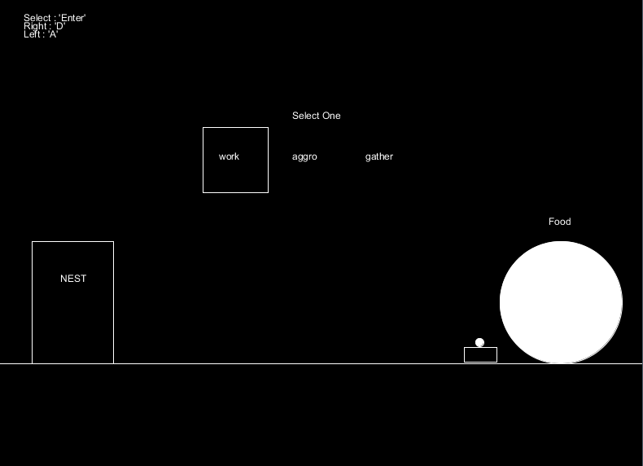

* Going back to source without food

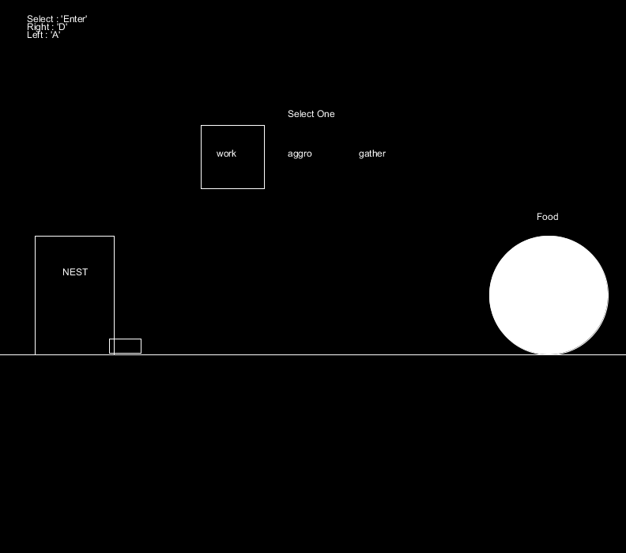

**Prototype 2 – Draw and Erase Paths for Ants**

I planned to make a draw and erase paths prototype for an ant so kids can move the ant. It could be a nice interactive game for children. At the beginning, ant stands on the ground and user can make holes under the ground. When ant sees a hole, it starts going down and stops when the hole finishes.

I was thinking about making paths in every direction and erase these paths but I only finished the horizontal paths in 1 hour. There are also some bugs about ant behaviour but It can be fixed in time.

* Beginning of the prototype

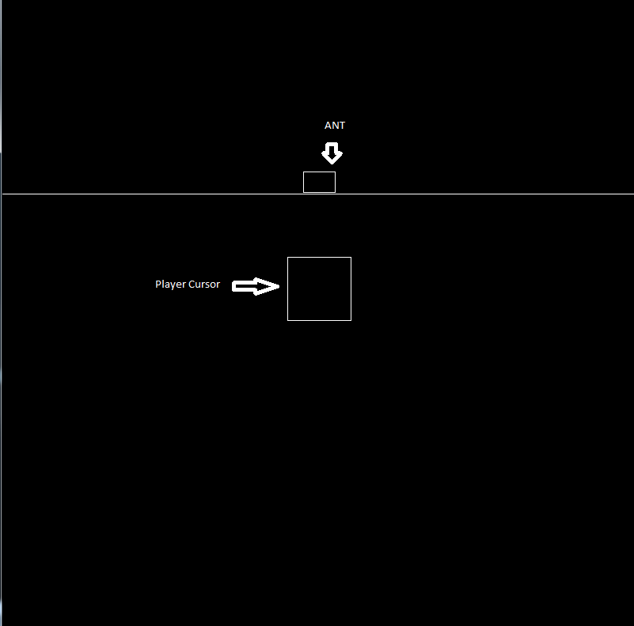

* Making a hole under the ant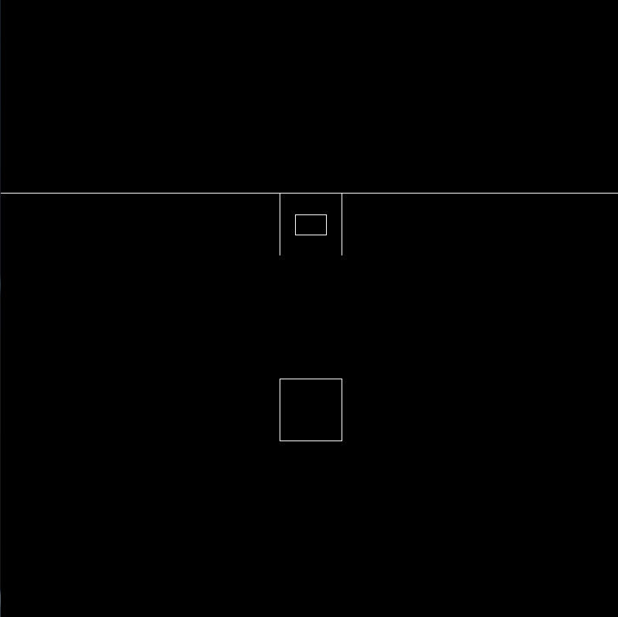
* Making 3th hole

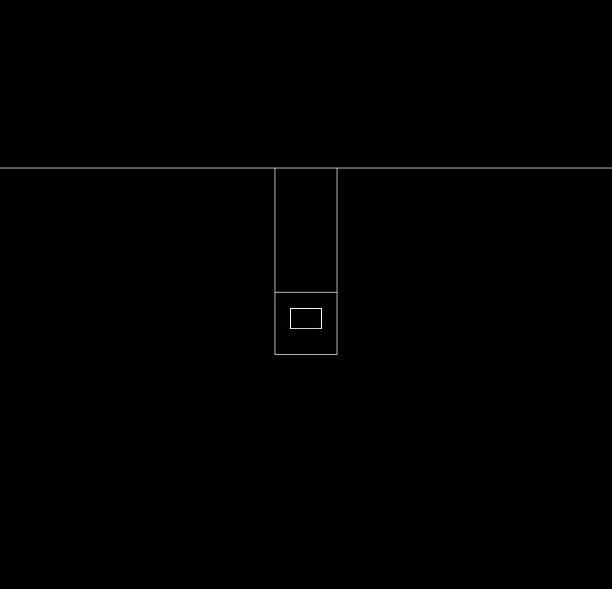

**Prototype 3 – Save the Ants**

For this prototype, I was thinking to collect all the ants on the way and bring them to home as a player. With this way, children can save all the ants from some danger.

I drew a path, a home and the ants on the way. User can move the player character up and down with W and S keyboard keys. When they on an ant, clicking enter key takes the ant and when they inside home, clicking enter again releases these ants so they saved.

* Beginning of the prototype

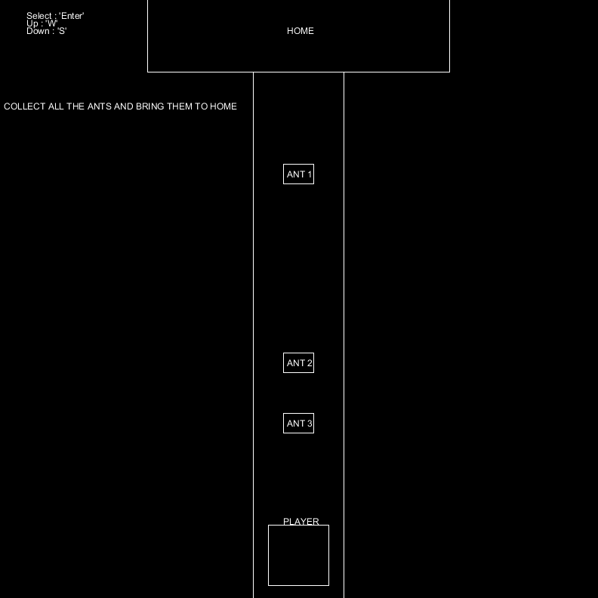

* Taking the 3rd ant

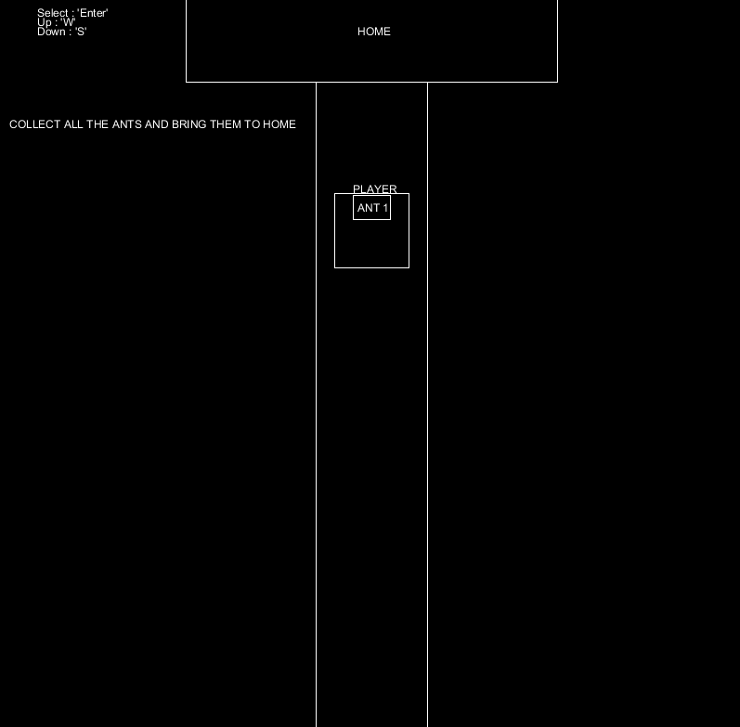

* Releasing the ants in home

